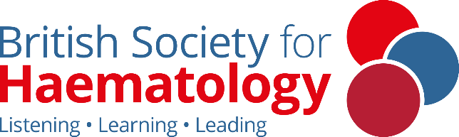

Haematology for Internal Medicine Trainees

Saturday 20 September

University of Leicester

This course supports IMT doctors in exploring and understanding Haematology clinical themes, core conditions and the training pathway. Taught in person with a focus on group work and networking, this course is suitable for resident doctors considering a career in haematology, or anyone working in healthcare seeking to deepen their understanding of haematology.

|  |  |
| --- | --- |
| 09:00 | Registration and tea and coffee |
| 09:30 | Welcome and outline of the day |
| 09:45 | Leukaemia and bone marrow failure – Drs. Sarah Wharin & Katherine Hodgson |
| 10:30 | Leukaemia and bone marrow failure: break out groups |
| 11:15 | Break: Tea/coffee |
| 11:30 | Lymphoma and Myeloma – Drs. Sapna Ladani & Rachel Fisken |
| 12:15 | Lymphoma and Myeloma: break out groups |
| 13:00 | Lunch |
| 13:45 | Red cell disorders and transfusion – Dr. Matt Player |
| 14:30 | Red cell disorders and transfusion: break out groups |
| 15:15 | Break: Tea/coffee |
| 15:30 | Thrombosis and Haemostasis – Dr. Karyn Longmuir |
| 16:15 | Thrombosis and Haemostasis: break out groups |
| 17:00 | How to get a Haematology training number – Dr. Frances Wadelin |
| 17:30 | Meeting close |

**Course fees:**

£35 – BSH Members

£70 – Non Members

[Book now and more information](https://b-s-h.org.uk/education/conference-and-events/events/2025-bsh-imt-day-leicester)

Take a look at our [free associate membership](https://b-s-h.org.uk/membership) for Foundation Doctors, IMTs and Health Professionals up to Band 7

**For any queries please contact** [**education@b-s-h.org.uk**](mailto:education@b-s-h.org.uk)